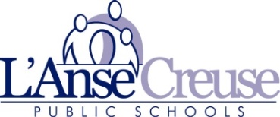

Middle School Summer Programs

*Middle School Summer Program offers a variety of exciting learning opportunities*

*for* ***L’Anse Creuse students*** *entering grades sixth through eighth grade.*

**Location: Middle School-North**

46201 Fairchild Rd, Macomb

Two 4 week Sessions: A - June 23 – July 15, 2021(Closed July 5)

(Monday – Thursday) B - July 19 – August 11, 2021

TIME: 8:00 am – 12:15 pm (Courses subject to change due to Enrollment)

ONE PROGRAM PER SESSION

Math Mindset  **OR**  Literacy Adventure

**6 – 8 Math Mindset (Free)**

*Available Face to Face and Virtual*

The academic program consists of mathematical mindset messages, number talks, problem based lessons, and classroom activities from the inspirational math series on [www.youcubed.org](http://www.youcubed.org)

(Average 20 students per class)

Classes are held 8:00am – 12:15pm

Snack Break- Bring snack/Water bottle

Click link for registration:

<https://www.lc-ps.org/programs/summer-programs/>

**Literacy Adventure (Free)**

*Available Face to Face and Virtual*

This course will sharpen your ELA skills with engaging, age-appropriate literary and informational reading selections. Students learn to read critically, analyze texts, and cite evidence to support ideas as they read. Vocabulary, grammar, and listening skills are taught through lessons that give students explicit modeling and practice.

(Average 20 students per class)

Classes are held 8:00am-12:15pm

Snack Break- Bring Snack/Water bottle

Click link for registration:

<https://www.lc-ps.org/programs/summer-programs/>

***Deadline*: Registration for 1 session or both sessions is required by *June 11, 2021*.**

**Register for Math Mindset OR Language Arts Enrichment per 4 week session**

**Academic Programs are Free**

***Registration for All Sessions Close June 11, 2021***

Questions may be directed to L’Anse Creuse Curriculum Office at *586.783.6300 x1310*