L’Anse Creuse Public Schools
Transitional Kindergarten
Building a Strong Foundation for Learning

What is Transitional Kindergarten?
Transitional Kindergarten, also known as TK, is a free program being offered in L’Anse Creuse for next fall. TK is the first of a two-year kindergarten sequence. Students attend TK followed by Kindergarten the next school year.

TK was created for children who would benefit from an additional year of growth and development before attending kindergarten. This program will allow our youngest learners the time they need to grow academically, socially, and emotionally in order to be fully prepared for kindergarten.

Is Transitional Kindergarten right for my child? Is my child eligible?
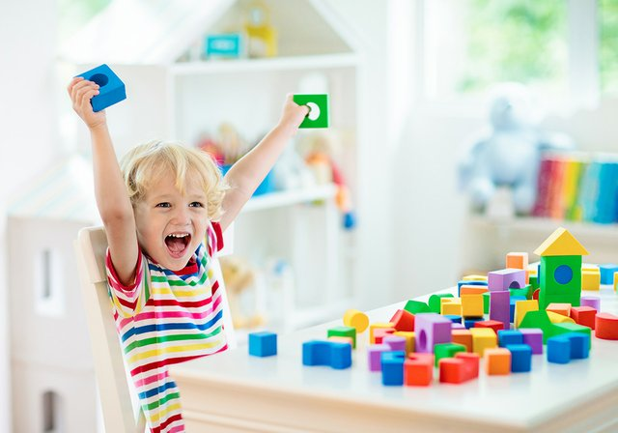
The TK program offers an alternative for children who are not yet ready for traditional kindergarten. If your child was born between June 1st and December 1st, if your child has not attended preschool, or if your child would benefit from the gift of time, you may want to consider TK. You know your child best, and we will work with parents to determine the best placement for students. Space is limited. If classes reach capacity, a waitlist procedure will be utilized.

What happens in a TK classroom?
TK is a full-day program which teaches Kindergarten standards with a focus on social/emotional development, oral language, fundamental literacy skills, and foundational math skills in a student-centered, active learning environment.
Classroom-TK will have their own classroom with a highly qualified, certified LCPS teacher and lower class size than our traditional kindergarten programs.
Specials Classes-TK students will participate in the same classes such as music, art, physical education and Spanish, as all elementary students.
Learning Environment-TK students will learn important foundational academic and social skills in a fun, yet challenging way. This TK experience will help them adjust to the elementary school environment and be fully prepared for kindergarten.

Where will the TK programs be located?
Depending on the interest/enrollment, TK programs will be offered at two elementary buildings. The specific buildings will be determined at a later date. After one year of TK, your child will return to their home school to attend Kindergarten.

Will bus transportation be provided?
All TK students residing in the LCPS attendance area may receive transportation, depending on location.

