INTENT TO PARTICIPATE FORM
SENIOR HONORS PROJECT

I, the undersigned, declare my intention to participate in the Senior Honors Project.

I recognize that I must:

- Conduct myself in a professional, businesslike manner at all times during the project.
- Maintain academic and graduation requirements for admission to the program throughout the semester.
- Maintain professionalism and integrity during the honors project program.
- Discuss my intentions with my parents/guardians and obtain their consent.
- Complete all project requirements on time. (see due date timeline for details)
- Meet with my Professional Supervisor, my Faculty Advisor and the Project Coordinator at designated times to discuss my plans for the project.
- Complete an evaluation and journal at the project’s conclusion.

I understand that my participation in the Senior Honors Project program is dependent upon meeting the above criteria, and is subject to the approval of the Faculty Senior Honors Project Committee. I further realize that I must place myself in a project of my interest for the required time period of three weeks with a minimum of thirty hours per week, minimum 77 total hours, and that I will not be paid. Finally, I understand that successful completion of the Senior Honors Project does not grant me credits, but that it will be noted on my high school transcript.

_______________________________________
Printed Name of Student

_______________________________________ ____________________
Signature of Student Date

_______________________________________
Signature of Parent/Guardian

Submit to Ms. O’Neal in the counseling office on or before February 8, 2019.

FACULTY AGREEMENT FORM
For participation in the Senior Honors Project

Teachers:
By signing this form, you agree that _________________________________________ is qualified by virtue of attitude and effort in your class, to participate in the Senior Honors Project beginning Friday, May 3rd. You also agree that because students participating in the project are required to complete 30 hours or more per week in a chosen career field, you will exempt him or her from class work and from final exams. You will calculate the final grade at the point of their departure from school. (This may not apply to AP, Dual Enrollment, ECM or CTE classes.)

1st Hour _____________________________________________

2nd Hour _____________________________________________

3rd Hour _____________________________________________

4th Hour _____________________________________________

5th Hour _____________________________________________

6th Hour _____________________________________________

__________________ ____________________ _____________________
Student’s Name (print) Parent/Guardian Name (print) Faculty Advisor Name (print)

__________________ ____________________ _____________________
Signature Signature Signature

__________________ ____________________ _____________________
Date Date Date

SENIOR HONORS PROJECT
PROPOSAL PREPARATION WORKSHEET – p. 1

Student Name _____________________________________

Student’s Contact Information

Home Phone # ___________________________

Cell Phone # ___________________________

Buisnesses under consideration:

Choice1
Name of Organization/Company ______________________________________

Address __________________________________

__________________________________

Phone # _______________________

Potential Professional Supervisor ______________________________________

Choice2
Name of Organization/Company ______________________________________

Address __________________________________

__________________________________

Phone # _______________________

Potential Professional Supervisor ______________________________________

Dates of meeting with above Professional Supervisor Candidates:

Choice1: ______________________ confirmed? Yes / No

Choice2: ______________________ confirmed? Yes / No

SENIOR HONORS PROJECT
PROPOSAL PREPARATION WORKSHEET – p. 2

In the area below, write a brief description of the project you wish to complete.

Specific Description of Project Tasks

What duties and responsibilities would you like to include as part of your project: (use as many lines as necessary – be very specific!)

- ________________________________________________________________

- ________________________________________________________________

- ________________________________________________________________

- ________________________________________________________________

- ________________________________________________________________

- ________________________________________________________________

- ________________________________________________________________

- ________________________________________________________________
SENIOR HONORS PROJECT
PROPOSAL PREPARATION WORKSHEET – p. 3

What hours are you absolutely unavailable, and what hours are you hoping to work to complete your project? You will negotiate these with your professional supervisor.

Remember to consider all previously scheduled commitments: (job, athletics, dual enrollment and AP classes and exam dates, etc.)

Complete a PROJECTED work schedule below. FINAL SCHEDULES DUE: April 24, 2019.

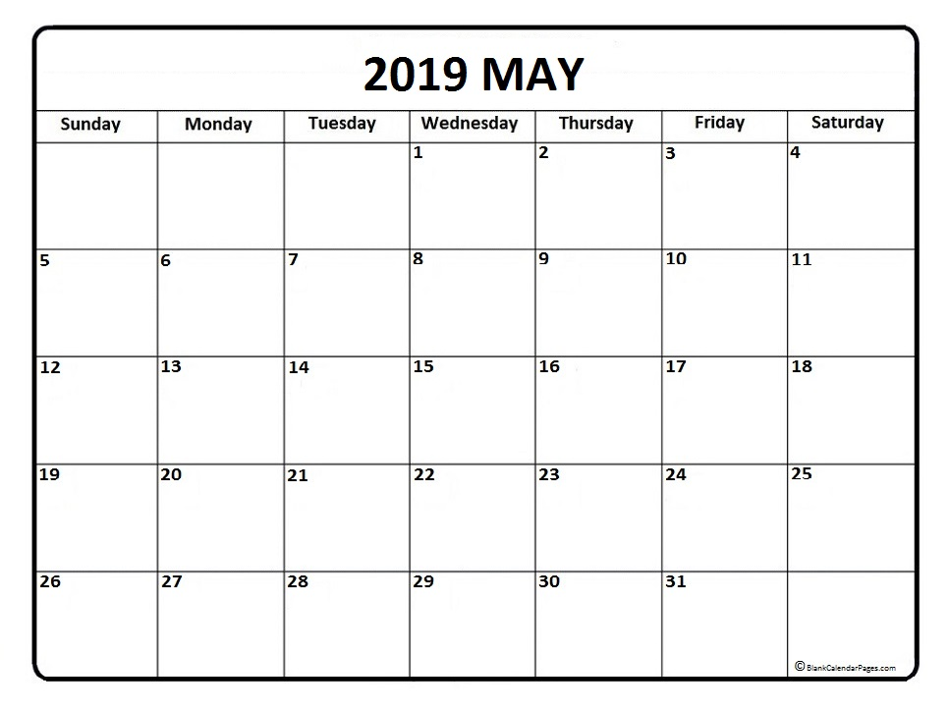

PROJECT PROPOSAL QUESTIONS – p. 4

Student Name _____________________________________

- What do you hope to gain from doing a Senior Honors Project?
Please be specific.

- Do you have an idea of a general occupational field in which you would like to do your Senior Honors Project?
If so, please describe.

- Have you ever done any work or exploration in this field?
If yes, give particulars – when, where, and in what capacity?
If no, what stimulated your interest in this field?
Be specific.

PROJECT PROPOSAL QUESTIONS – p. 5

- Do you have any ideas for people to contact to be your Professional Supervisor? If so, who?

- Have you any history of physical illness, allergies, or disability which would require any special consideration while on a Senior Honors Project?
If yes, please list.

- Have you any particular skills that you feel would aid you in your project?
Explain.

- Will you have access to the transportation necessary to do an out of school project? What conflicts might you have in completing 30 hours per week?

SENIOR HONORS PROJECT
PROFESSIONAL INTERVIEW

DATE OF INITIAL CONTACT: ___________________________________

METHOD OF CONTACT (EMAIL, PHONE, IN-PERSON):________________

DATE OF PROFESSIONAL INTERVIEW:______________________________

METHOD OF INTERVIEW (PHONE, IN-PERSON):_____________________

LOCATION OF PROFESSIONAL INTERVIEW:__________________________

What is the senior honors project and what are the basic requirements?

What is the major purpose of your project?

What do you hope to gain from your experience?

What will be your specific duties and responsibilities?

What will be your approximate schedule?

Obtain the signature of your Professional Supervisor on the contract of agreement at the end of your professional interview. Attach all email communication to the back of this page.

SENIOR HONORS PROJECT
CONTRACT OF AGREEMENT

Professional Supervisor:

I agree to be the supervisor of this student’s Senior Honors Project, and I agree to contact the school right away should any difficulties arise. I will also complete an evaluation of the project and the student’s performance for use by the school.

_____________________ ___________________________________________
Date Signature

Student:

I agree to work on the Senior Honors Project for 77 hours during my approved school leave. I further agree to diligently assume all of the duties and responsibilities that may realistically be assigned.

_____________________ ___________________________________________
Date Signature

Parents/Guardians:

I have read the description of the Senior Honors Project, and the Project Proposal my child has prepared. I approve of the project, and I am willing to assume responsibility for my child while he/she is pursuing this program, and for the entire duration of the project, should the school approve it.

_____________________ ___________________________________________
Date Signature

WAIVER AND RELEASE OF LIABILITY FORM

The undersigned is a student at L’Anse Creuse High School – North and the student’s parent or legal guardian. The school has requested permission to conduct an academic program at facilities of _____________________________________________________________. This facility is granting access to the student subject to, and in reliance upon your providing to it this waiver and release of liability form.

- The undersigned acknowledges that the student is not an employee of ________________________________________________.

- The undersigned knowingly and voluntarily releases ________________________________, its officers, directors, employees, agents, etc. from any and all claims and demands resulting from injury (or death) of any person or damage to any property resulting from participation in the program or any activities incidental thereto, including, specifically, such claims and demands as may arise out of or be alleged to arise out of the negligence (but not to the negligence) of ________________________________, its officers, directors, employees, agents or representatives.

- The student will abide by all rules and regulations of ________________________________ and you assume full responsibility for the student’s failure to do so.

- The student will not disclose to anyone information which ________________________________ indicates to him/her is confidential, and will review with ________________________________ any papers, articles, or other material prepared by the student prior to its publication.

The undersigned have read this waiver and release of liability form and fully understand its provisions, and further, understand that no officer, director, employee, agent or representative is authorized to vary its terms or provisions or to make any representations contrary to the provisions hereof.

_____________________________ ______________________________
Student’s Name (print) Parent/Guardian Name (print)

_____________________________ ______________________________
Signature Signature

_____________________________ ______________________________
Date Date
SENIOR HONORS PROJECT
FINAL PROPOSAL ESSAY DIRECTIONS

Requirements:

- Cover sheet must be accurate and complete.
- Proposal must be typed, double-spaced, in complete sentences and in paragraph form.
- Proposal essay must include student’s last name on each page, bottom right corner.
- Proposal essay must be between 200-250 words.
- Proposal essay must address each of the bullet points below.
- Final paragraph must explain your future goals in relation to your project experiences.
- Staple your proposal cover sheet to the top of your essay.

Directions:

Complete the project proposal cover sheet. Using your proposal preparation worksheet responses, compose a 200-250 word proposal essay that contains the following:

- Why did you choose this occupational field?
- Describe the faculty advisor you chose and explain why you chose him/her.
- Describe your interview with your professional supervisor.
- Name the organization and its role and/or history.
- Who will you be shadowing in the organization?
- What specific duties will you be responsible for during your project?
- What specific skills do you hope to acquire during your project?
- Why do you feel you will be successful at this project?
- What do you anticipate will be your biggest challenge?
- How will your participation in this project benefit you in your future?

SENIOR HONORS PROJECT
FINAL PROPOSAL ESSAY COVER SHEET

Student Name _____________________________________

Faculty Advisor _____________________________________

Name of Professional Supervisor ______________________________________

Name of Organization/Company ______________________________________

Address __________________________________

City/Zip __________________________________

Phone # _______________________

Email __________________________________

Interview Date with Professional Supervisor ______________

Job Title __________________________________________________

Job Description _________________________________________________

Visit Date with Faculty Advisor _____________________

SENIOR HONORS PROJECT
FINAL WORK SCHEDULE
COPY 1: MS. O’NEAL
COPY 2: FACULTY ADVISOR

Student Name _____________________________________

Faculty Advisor _____________________________________

Professional Supervisor ______________________________

COMPLETE HOURS YOU WILL BE ON SITE FOR YOUR PROJECT.

JOURNAL SUMMARY
Students: complete and bring to final meeting.
You may include a daily or periodic thoughts journal as well.

NAME: ______________________________________________________

LOCATION OF PROJECT: ________________________________________

PROFESSIONAL SUPERVISOR: ___________________________________

FACULTY ADVISOR: ___________________________________________

1.) Describe what you did during your project.

2.) List 3 or more positive aspects of this career.

3.) List 3 or more negative aspects of this career.

4.) How has this experience helped you determine your own future career plans?

SELF-EVALUATION
SENIOR HONORS PROJECT

NAME: ______________________________________________________

PROFESSIONAL SUPERVISOR: ___________________________________

LOCATION OF PROJECT: ______________________________________

CO. ADDRESS: __________________________________
__________________________________

CAREER AREA: _______________________________________________
(ex. Law, art, journalism, etc…)

- Describe the nature of your project.

- Describe a typical day. What were some of your duties and responsibilities?

- What led you to choose this project?

- How do you feel that you benefitted from doing a Senior Honors Project? What did you gain that you could not have gained by remaining in class?

- Describe any aspects of your project that turned out to be unsatisfactory. Explain why you believe this happened.

- Were any aspects of the project surprising to you? If so, what?

- What conclusion, if any, did you reach about your own interest in the field of work you sampled?

- What recommendations would you make to future students planning to do a similar Senior Honors Project?

- What suggestions would you make to your Professional Supervisor regarding future Senior Honors Projects?

- What suggestions do you have for your Faculty Advisor or the Project Coordinators?

- If you had to make the choice again, would you still choose to participate in Senior Honors Project? Explain.

- Rate your project on a scale of 1-10, with 1 being “waste of time” and 10 being “extremely worthwhile.” Defend your rating.

PROFESSIONAL SUPERVISOR’S EVALUATION
SENIOR HONORS PROJECT

Student’s Name: ________________________________

Organization: __________________________________

EVALUATION OF THE PROGRAM

- Were the goals and purposes of the Senior Honors Project program made clear to you via our communication and your conversation with the student? If not, what specific changes would you suggest?

- Did this project lend itself to independent work, or was there a need from strong direction from you?

- Did the student accomplish what you expected in this project? Please explain.

EVALUATION OF THE STUDENT

- Did you find that you could rely on the student? Did you feel confident assigning responsibilities?

- How well did the student relate to you and to others with whom he/she worked?

- With what, if any, aspects of the project were you dissatisfied?

- Would you be willing to supervise another of our students in a similar project in future years?

- Please feel free to make any additional comments.

PLEASE RETURN THIS EVALUATION BY MONDAY, MAY 20TH.

Fax: 586-493-5276 ATTN: Lori O’Neal
Email: Lori O’Neal at oneallo@lc-ps.org
OR
Return directly to student by May 20TH, meeting at 2:20pm.

Professional Supervisor: ___________________________________

Signature: ____________________________________

Thanks again!

FACULTY ADVISOR EVALUATION
To be submitted at final meeting.

YOUR NAME: ________________________________________________

STUDENT’S NAME: ___________________________________________

LOCATION OF PROJECT: _____________________________________

DATE OF VISIT: _____________________________________________

- Did the student communicate with you on a regular basis?

- How well did the student relate to others with whom he/she worked?

- Did the student exhibit professional conduct and communication on the job? (include dress, speech, manner, behavior, etc.)

- Did the student accomplish the project goals?

- What impressed you most about the student and/or the project?

- What, if any, aspects of the student and/or the project did you find unsatisfactory?

- Please make any additional comments you may have.

__________________________________________ __________________
Signature Date

