AP Physics 1/C Summer Work – Mr. Voydanoff

Your completed summer work is due the first day of class.

The exercises below are a review of the prerequisite math skills that you need to succeed in AP Physics 1. Be sure to read all directions throughout the packet as there are different requirements for each section. All work must be completed on the pages below in the area provided. Final answers can be in fractions and in terms of mathematical constants (π, e, i, etc.).
Your work must be legible and linear, and I must be able to follow it easily. Please no incoherent jumping around the page. Mark your final answers by either circling or boxing them. If you use scrap, please attach it to the back and make sure it is clearly labeled.
Do not copy work from another student for your own integrity and for your own benefit. Most colleges/employers look for candidates who are self-sufficient. If you have trouble with something, please, LOOK IT UP! Use a math book or the Internet for reference. No physics is needed for this packet. If you have difficulty, please do not hesitate to email me at voydapa@lc-ps.org.

Significant Figures and Scientific Notation Review

- How many significant figures do the following numbers have?

  - 6.001 Answer: d.) 27.00 Answer:

  - 0.0080 Answer: e.) π Answer:

  - 206,000 Answer:

Directions: Find the following. Final answers should be in scientific notation with the correct number of significant figures.
- (5.0 x 10⁻⁸) (2.9 x 10²) 3.) (3.25 x 10⁴ + 7.4 x 10³)

4.) 6.000 x 10⁻¹¹ 1.00 x 10²⁶ 5.) 8400
2.00 x 10⁷ 1.2 x 10⁷

Unit Conversions Review
- Finish the SI prefix table below. Follow the example of the centi- prefix. You will need to know these.
Symbol | Name | Numerical  Equivalent
n
μ
m
c | centi | 10-2
k
M
G

- 16.7 kilograms is how many grams?

- 560 nm is how many meters?

- 15 years is how many seconds?

- 8.99 x 10⁹ seconds is how many years?

- 2.998 x 10⁸ m/s is how many kilometers per hour?

Trigonometry Review
Directions: Use the figure below to answer problems 15-25. Simplify as much as you can.

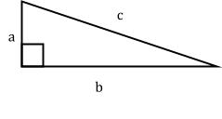
- Find c if given a and b. 13.) Find a if given b and c.

14.) Find a if given c and θ. 15.) Find b if given a and θ.

16.) Find c if given b and θ. 17.) Find θ if given b and c.

18.) Find θ if given a and b. 19.) If a = 2.0 and c = 7.0, what is b?

20.) If c = 10.0 and θ = 60°, what is b? 21.) If a = 12.0 and θ = 30°, what is b?

- Using the properties of triangles, prove that ∠A ≅ ∠C in the drawing below.
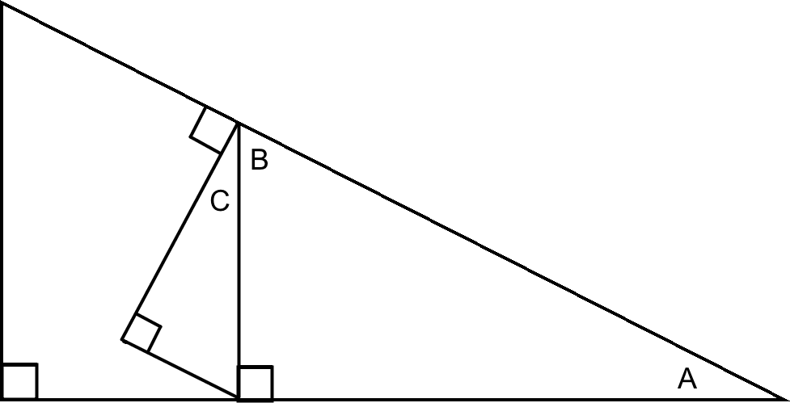

Answer:

- For what angles (in degrees) does sin θ ≈ θ? Describe why mathematically.

- Complete the table below without using a calculator.

θ | 0° | 30° | 45° | 60° | 90°
sin θ
cos θ
tan θ

- 360 degrees = radians. 26.) 4.5 revolutions = radians.

- Find the length of an arc with a radius of 6.0 m swept across 2.5 radians.

- Find the length of an arc with a radius of 10.0 m swept across 100 degrees.

Algebra Review
Directions: Solve the following equations for the given variable and conditions. Simplify if needed.

Example: 2x + xy = z. Solve for x. x(2 + y) = z
x = z . 2 + y
- v₁ + v₂ = 0. Solve for v₁. 30.) a = v/t . Solve for t.

31.) v ² = v ² + 2ad
f i
A.) Solve for v_{i}. B.) Solve for d.

- d_{f} = d_{i} + v₀t + ½ at²
A.) Solve for v_{o}. B.) Solve for t, if v_{o} = 0.

C.) Solve for t, if d_{i} = d_{f}.

- F = m v_{f} — v_{i}

t_{f} — t_{i}
A.) Solve for v_{f}, if t_{i} = 0. B.) Solve for t_{f}, if v_{f} = 0 and t_{i} = 0.

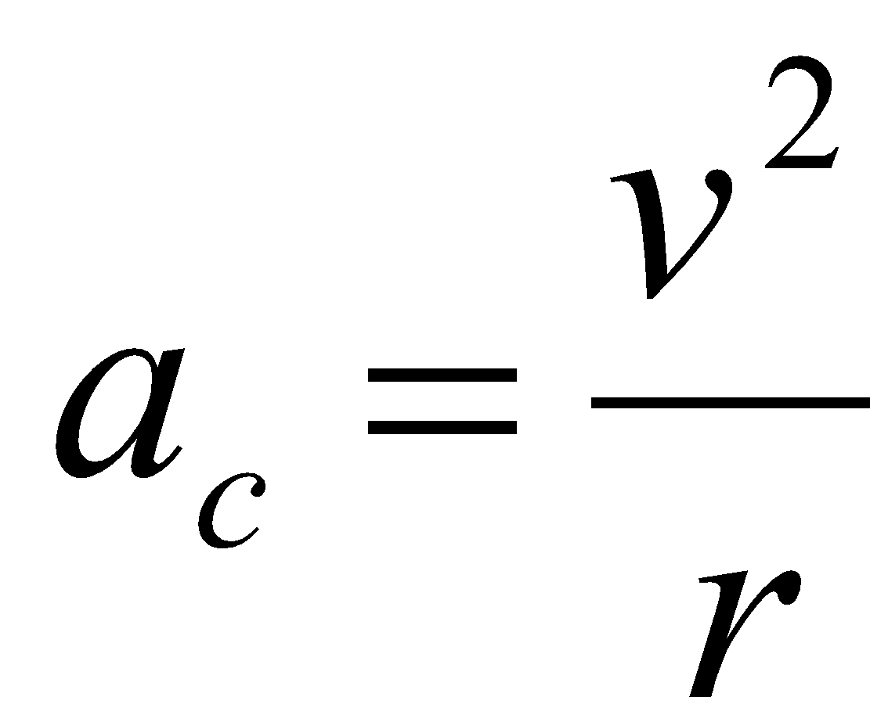
- . Solve for v. 35.) mgsinθ = μmgcosθ. Solve for θ.

- ½ mv ² + mgh = ½ mv ² + mgh
f f i i
A.) Solve for h_{f}, if h_{i} = 0 and v_{f} = 0. B.) Solve for v_{f}, if h_{f} = 0.

- Ft = mv_{f} — mv_{i}. Solve for v_{f}. 38.) m₁v_{i1} + m₂v_{i2} = (m₁ + m₂)v_{f}. Solve for v_{i,2}.

- m₁v_{i1} + m₂v_{i2} = m₁v_{f1} + m₂v_{f2}. Solve for v_{f,2} if v_{i,1} = 0.

- (F₁sinθ)r₁ + (—F₂sinφ)r₂ = 0. Solve for r₂.

- —kx + m(—g) = 0. Solve for m. 42.) 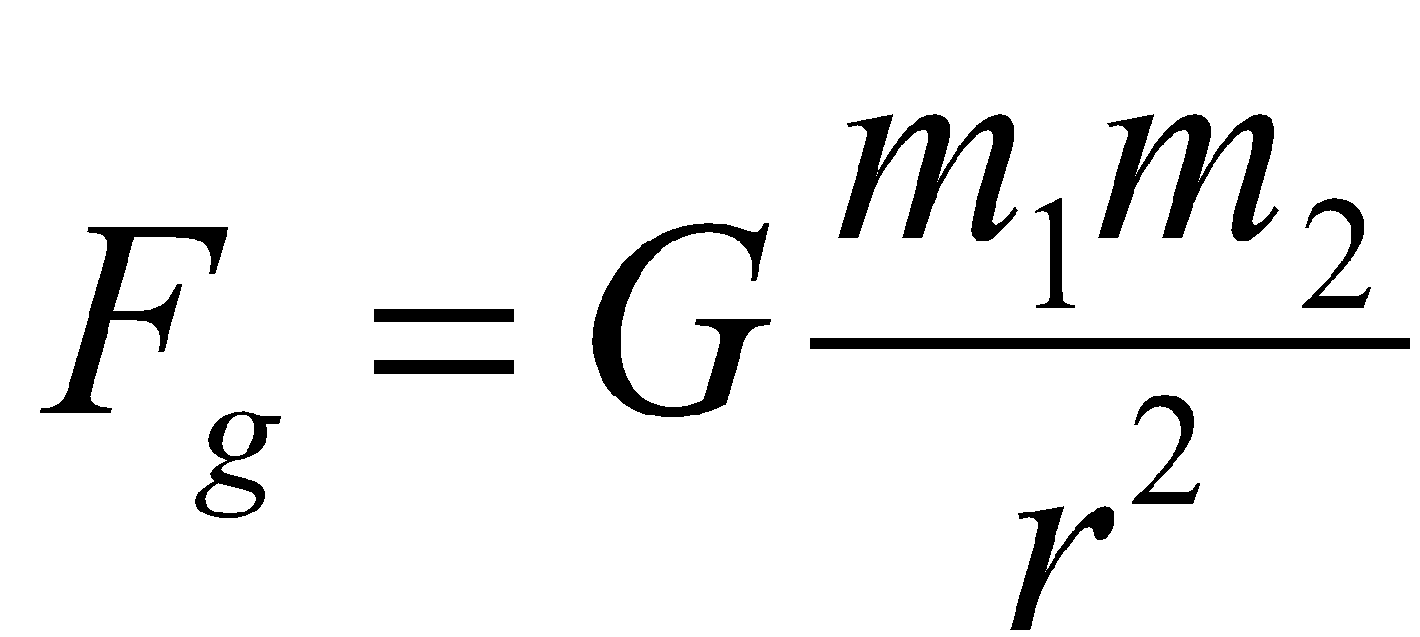 . Solve for r.

43.) L — Lcosθ = v²/2. Solve for L.

44.) 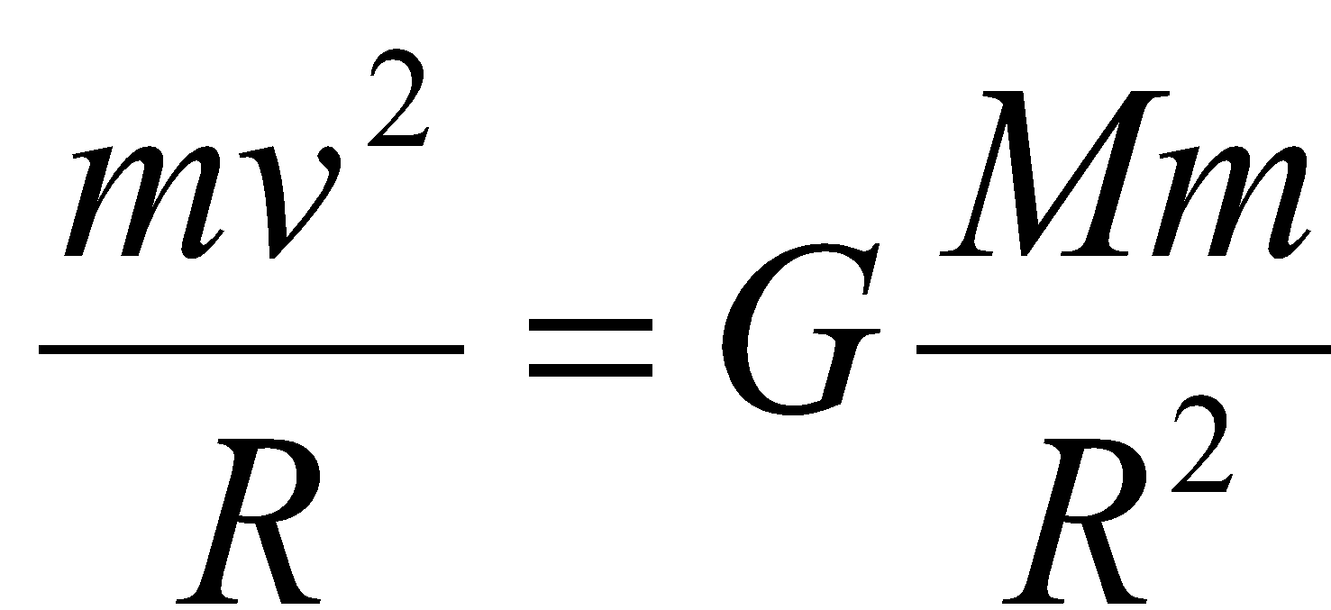 . Solve for v. 45.) 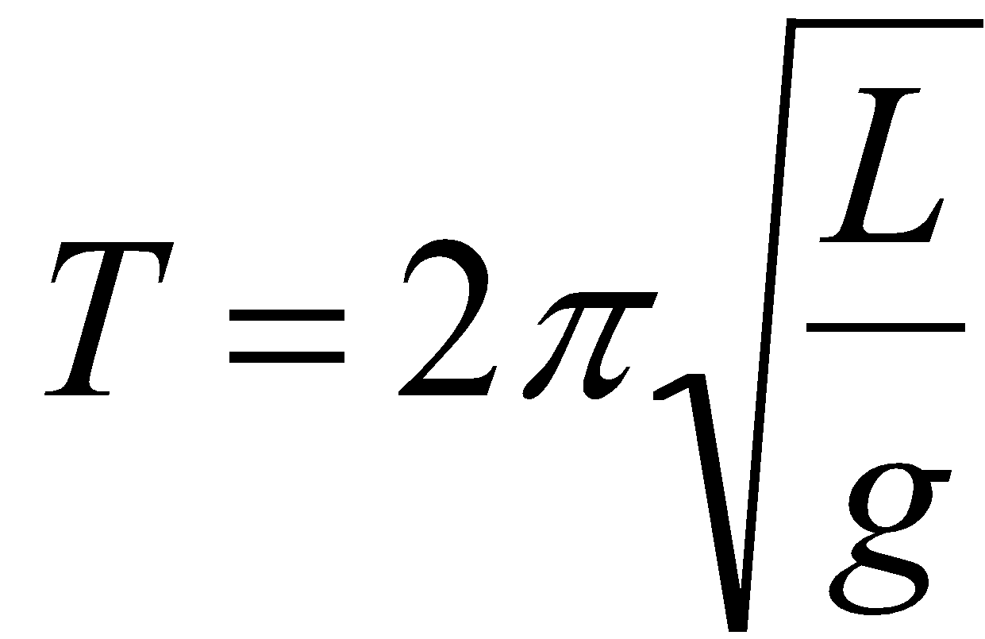 . Solve for g.

- ½ mv ² + ½ kx² = ½ mv ² + mgh. Solve for x if v = 0.
f i f

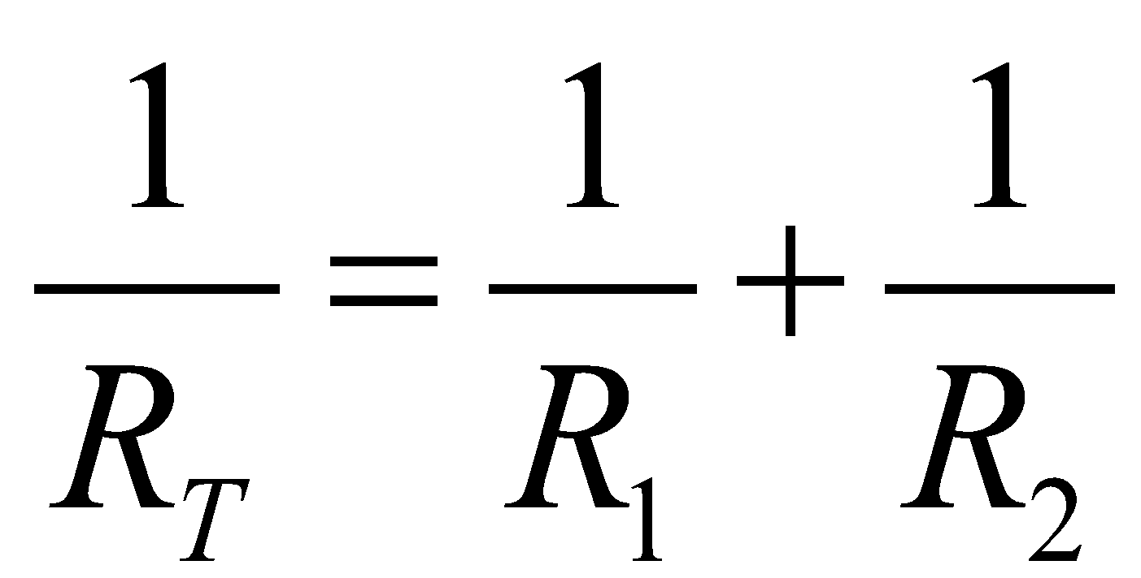
- . Solve for R_{T}.

Miscellaneous
Directions: Simplify without using a calculator. Remember to show all of your work.
- 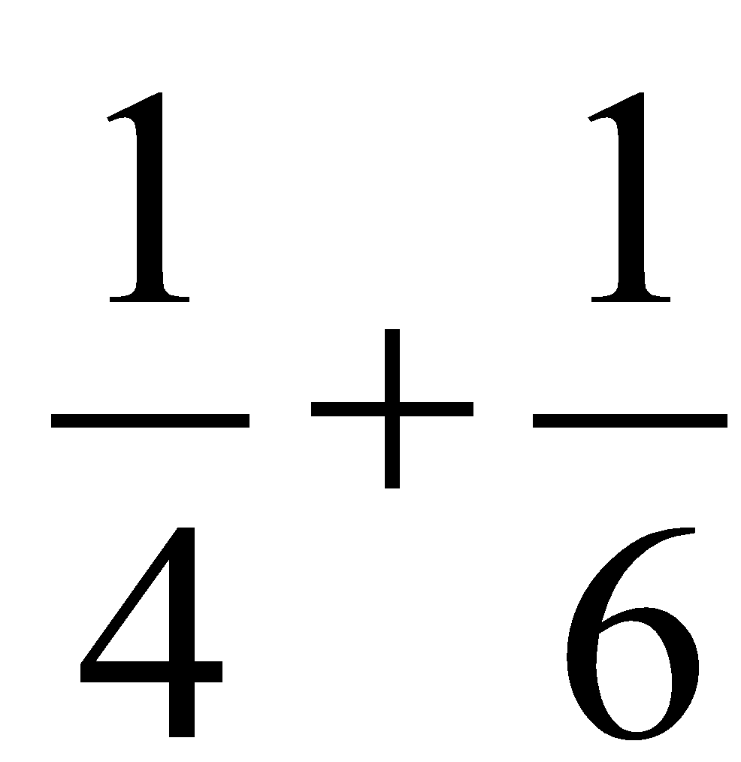 49.) 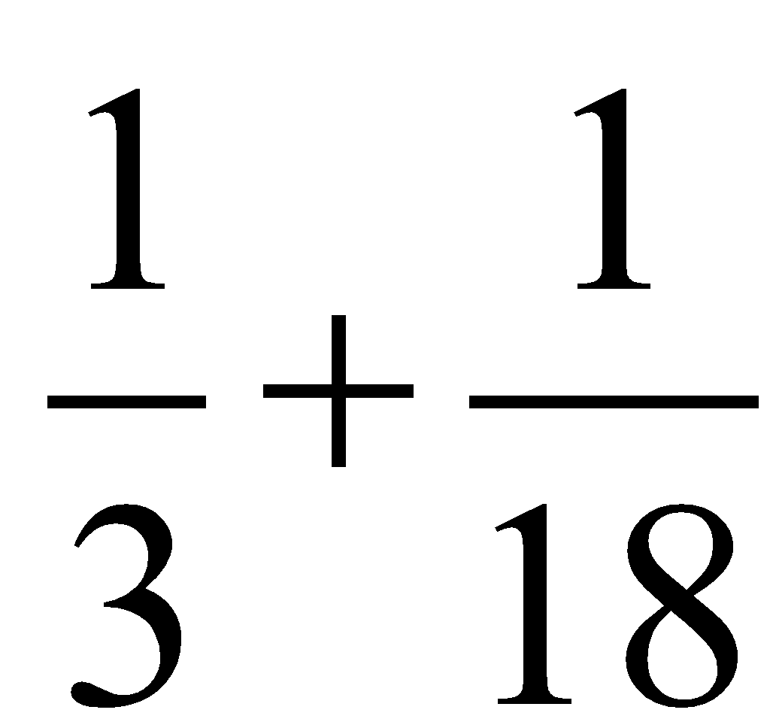

- Consider:
  - z = x/y
  - c = ab
  - l = m — n
  - r = s²/t²

- As x increases and y stays constant, z .

- As y increases and x stays constant, z .

- As x increases and z stays constant, y .

- As a increases and c stays constant, b .

- As c increases and b stays constant, a .

- As b increases and a stays constant, c .

- As n increases and m stays constant, l .

- As l increases and n stays constant, m .

- If s is tripled and t stays constant, r is multiplied by .

- If t is doubled and s stays constant, r is multiplied by .

Systems of equations
Conceptual Question:
- How many equations are needed to solve…
- for 1 unknown variable?
- for 2 unknown variables?
- for 3 unknown variables?

Use the equations in each problem to solve for the specified variable in the given terms. Simplify.
- F_{f} = μF_{N} and F_{N} = mgcosθ. Solve for μ in terms of F_{f}, m, g, and θ.

- F₁ + F₂ = F_{T} and F₁·d₁ = F₂·d₂. Solve for F₁ in terms of F_{T}, d₁, and d₂.

- F_{c} = ma_{c} and a_{c} = v²/r. Solve for r in terms of F_{c}, m, and v.

- 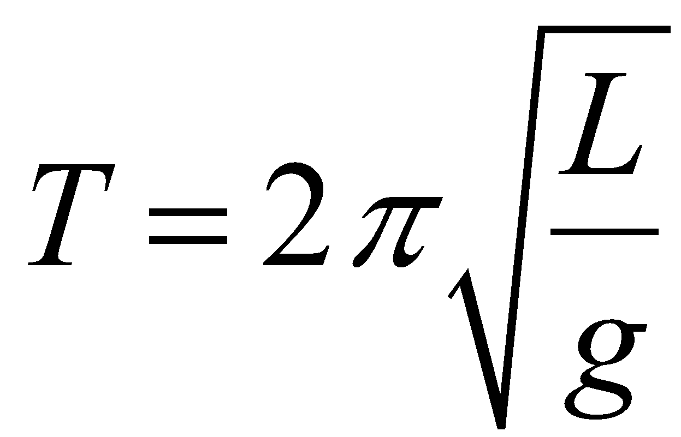 and 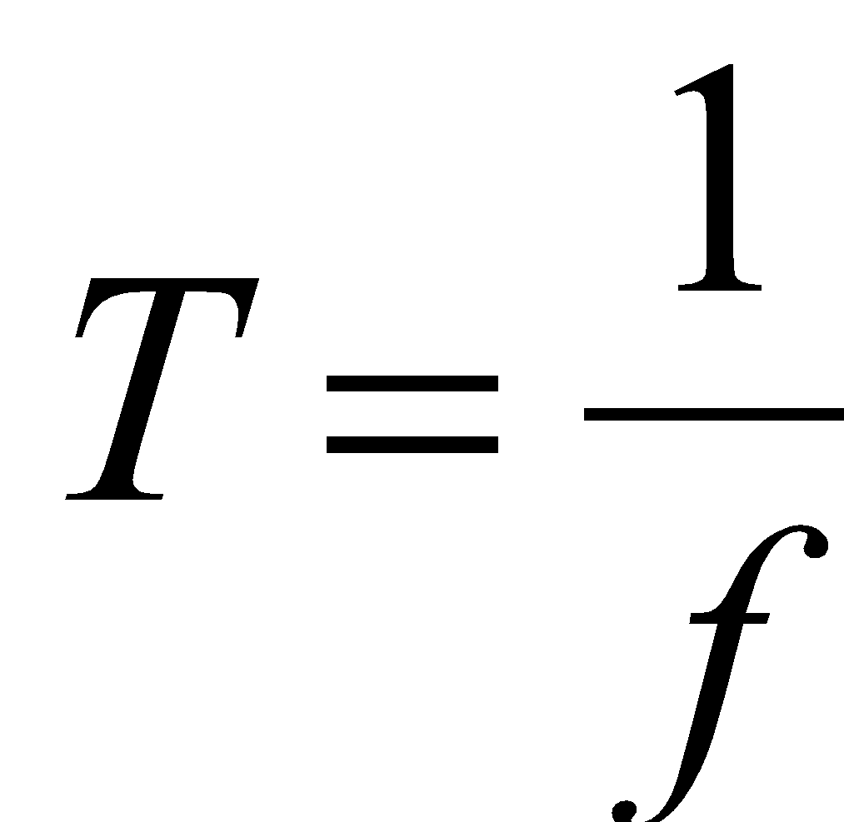 . Solve for L in terms of π, g, and f.

PAGE INTENTIONALLY LEFT BLANK FOR SCRAP WORK

Graphing Equations

- If r = c – x*t was graphed on an r vs. t graph, what would the following be?
Slope: y-intercept:

- On the y vs. x graphs below, sketch the relationships given.

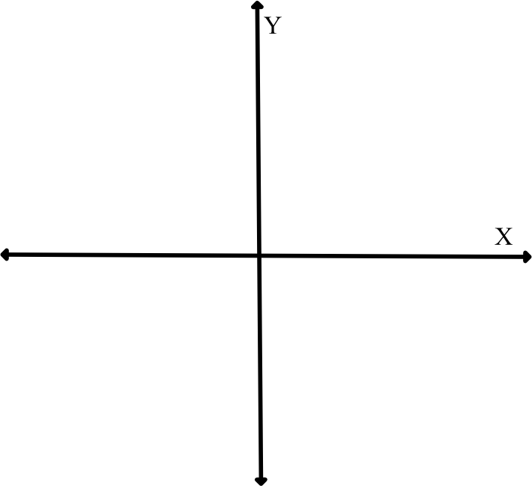
a.) y = mx + b, if m > 0 and b = 0. b.) y = mx + b, if m < 0 and b > 0.

c.) y = x² d.) 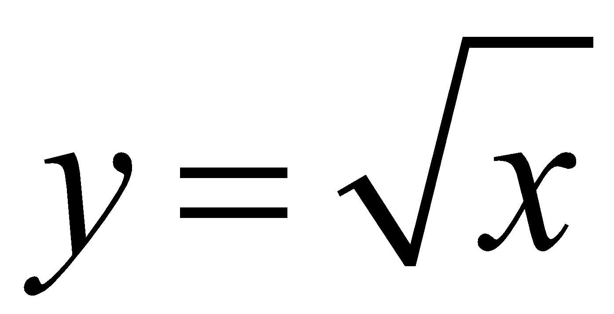
e.) y = 1/x f.) y = 1/x²

g.) 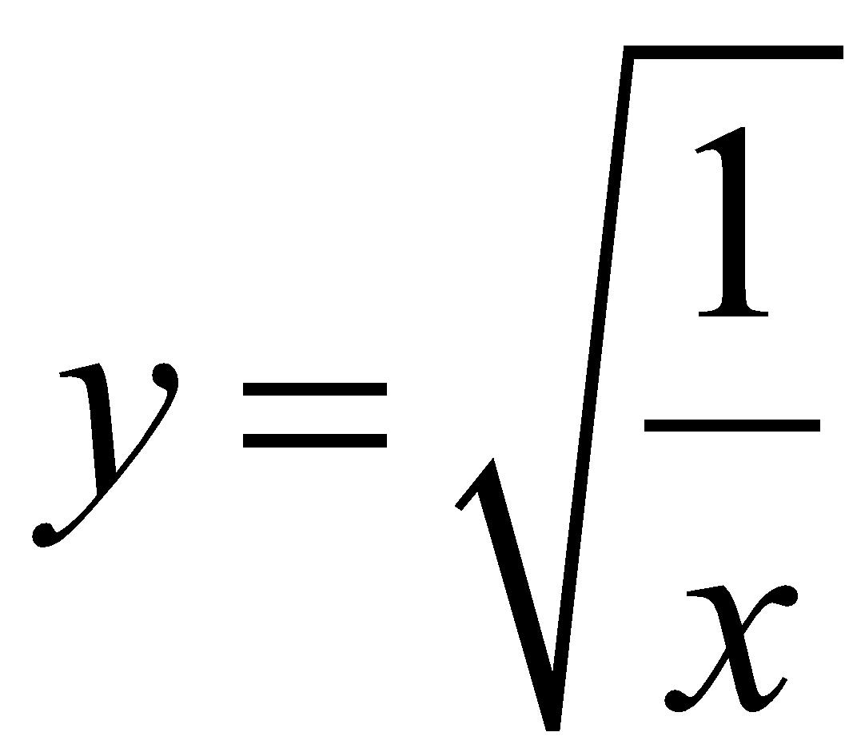 h.) y = sin(x)

PAGE INTENTIONALLY LEFT BLANK FOR SCRAP WORK

Marbles in Cylinder Lab

You received a graduated cylinder with three identical marbles and an unknown amount of water already in it. You placed extra identical marbles in the cylinder and obtained the data below. Use the data to graph a best-fit line showing the relationship between the water level and the number of marbles. The y-intercept should be visible on the graph. Label your axes and include units.
From the graph, determine a mathematical formula for the water level for any number of marbles. Lastly, give an explanation of your formula in words. Make sure to give an explanation of the slope and y-intercept of your formula.

Number of Marbles  in Water | Water level (mL)
3 | 58
4 | 61
5 | 63
6 | 65
7 | 68
- Graph below

- Formula:

- Explanation of the formula in words: (Include the meaning of the slope and y-intercept.)

