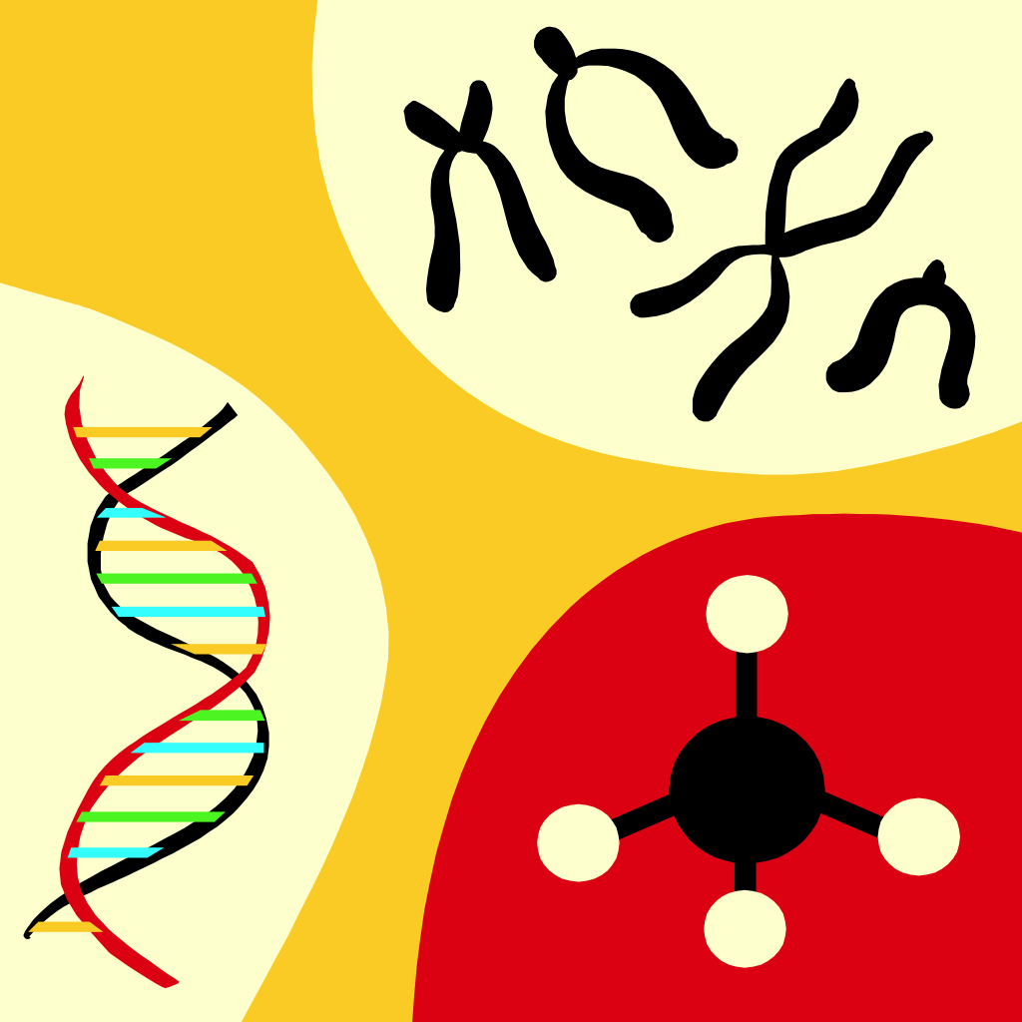

Welcome to AP Biology!
I am very happy you have chosen to take AP Biology as part of your curriculum here at L’Anse Creuse High School - North! I can’t wait for the course to begin, and to teach you!
Course Overview:
The Advanced Placement Biology curriculum is equivalent to a college course usually taken by biology majors during their first year of college. Students obtain credit by successfully passing the AP Biology exam at the end of the course. The course differs significantly from a high school Biology course with respect to the kind of textbook used, the range and depth of topics covered, the kind of laboratory work done by students, and the time and effort required by the students. The primary emphasis of the course is on developing an understanding of concepts; a grasp of science as a process rather than as an accumulation of facts; personal experience in scientific inquiry; recognition of unifying themes that integrate the major topics of biology; and the application of biological knowledge and critical thinking to environmental and social concerns. The course is designed to offer students a solid foundation in introductory college-level biology. By structuring the course around the four big ideas, enduring understandings, and science practices, this will assist students in developing an appreciation for the study of life, and will help them identify and understand unifying principles within a diversified biological world.

What we know today about biology is a result of inquiry. Science is a way of knowing. Therefore, the process of inquiry in science and developing critical thinking skills is the most important part of this course.

At the end of this course, students will have an awareness of the integration of other sciences in the study of biology, understand how the species to which we belong is similar to, yet different from, other species, and be knowledgeable and responsible citizens in understanding biological issues that could potentially impact our lives.

Prerequisite: Overall grade of “B” or better in Biology, and successful completion of Chemistry. Teacher recommendation required. This second year biology course is equivalent to a college-level introductory biology course. Major areas of study include molecules and cells, heredity and evolution, and organisms and populations. The major goals of this course are to help students develop a conceptual framework for modern biology and to help students gain an appreciation for science as a process. Completion of this course will prepare students for the AP Biology exam. Students electing this course should be highly motivated, self-disciplined and inquisitive.

Textbook & Study Resources:
- Urry, Lisa A., et al. Campbell Biology 12th Edition. Pearson, 2021.
- Barron’s AP Biology 2026 Premium Prep Book

Required Materials:
- XL 3-ring binder with dividers
- Standard size, loose leaf notebook paper
- Pencils with erasers
- Colored pencils
- Black and Blue ink pens
- Access to the internet, a printer, & your school-issued Chromebook
- Calculator
Instructional Context (Course Time):
AP Biology is taught to sophomores, juniors and seniors at a high school that employs a regular day schedule, which is a 1 hour class period, 5 times a week.

AP Biology Content for the 2025-2026 School Year:
Unit 1: Chemistry of Life
Unit 2: Cell Structure and Function
Unit 3: Cellular Energetics
Unit 4: Cell Cycle
Unit 5: Heredity
Unit 6: Gene Expression and Regulation
Unit 7: Natural Selection
Unit 8: Ecology

Exam Format
The AP Biology Exam has question types and point values that remain stable and consistent from year to year, so you and your students know what to expect on exam day.
Section I: Multiple Choice
60 Questions | 1 hour 30 Minutes | 50% of Exam Score
- Individual questions
- Sets of questions with 4–5 questions per set
Section II: Free Response
6 Questions | 1 hour 30 Minutes | 50% of Exam Score
- There are 2 long questions and 4 short questions. Long questions are worth 8–10 points each; short questions are worth 4 points each.
- The long questions ask students to:
  - Interpret and evaluate experimental results
  - Interpret and evaluate experimental results with graphing
- The short-answer questions assess students’ understanding of the following:
  - Scientific investigation
  - Conceptual analysis
  - Analysis of a model or visual representation
  - Data analysis
AP Calculator Policy and Equations and Formulas Sheet
A four-function (with square root), scientific, or graphing calculator may be used on the exam.
Students are permitted to use the AP Biology Equations and Formulas Sheet on the exam. This resource is also available in Appendix A of the CED.

AP Biology Exam Weighting Per Unit Topic
Units Exam Weighting Unit 1: Chemistry of Life 8–11% Unit 2: Cell Structure and Function 10–13% Unit 3: Cellular Energetics 12–16% Unit 4: Cell Communication and Cell Cycle 10–15% Unit 5: Heredity 8–11% Unit 6: Gene Expression and Regulation 12–16% Unit 7: Natural Selection 13–20% Unit 8: Ecology 10–15%

The Investigative Laboratory Component:
The course is also structured around inquiry in the lab and the use of the seven science practices throughout the course.

Students are given the opportunity to engage in student-directed laboratory investigations throughout the course for a minimum of 25% of instructional time. Students will conduct a minimum of eight inquiry-based investigations (two per big idea throughout the course). Additional labs will be conducted to deepen students’ conceptual understanding and to reinforce the application of science practices within a hands-on, discovery based environment. All levels of inquiry will be used and all seven science practice skills will be used by students on regular basis in formal labs as well as activities outside of the lab experience. The course will provide opportunities for students to develop, record, and communicate the results of their laboratory investigations.

Science Practices:
- The student can use representations and models to communicate scientific phenomena and solve scientific problems.
- The student can use mathematics appropriately.
- The student can engage in scientific questioning to extend thinking or to guide investigations within the context of the AP course.
- The student can plan and implement data collection strategies appropriate to a particular scientific question.
- The student can perform data analysis and evaluation of evidence.
- The student can work with scientific explanations and theories.
- The student is able to connect and relate knowledge across various scales, concepts and representations in and across domains.

Units/Chapters of Instruction:
Unit 1: Introduction to Study of Life & Chemistry (Chapters 1 - 3)
Unit 2: Biochemistry & Introduction to the Cell (Chapters 4 - 7)
Unit 3: Cellular Energy & Related Processes (Chapters 8 - 10)
Unit 4: Cell Communication & The Cell Cycle (Chapters 11 - 12)
Unit 5: Genetic Basis of Life (Chapters 13 - 15)
Unit 6: Gene Activity & Biotechnology (Chapters 16 - 21)
Unit 7: Evolution & Phylogeny (Chapters 22 - 27)
Unit 8: Ecology (Chapters 51, 52.2, 53 - 55)

Binder:
You can have the 3-ring binder divided into the following categories and labeled with tabs:
Section 1: Lecture Notes
Section 2: Worksheets
Section 3: Quizzes/Tests
Section 5: Miscellaneous

CALENDAR:
If time permits, a monthly calendar will be provided for you that shows the what, when, and how of the class. For that reason, NO LATE PAPERS (unless you are absent that day). When you are absent, come prepared to continue the class. When absent work is obtained, you have the exact amount of days to turn in the work as you were gone.

**All assignments will be uploaded in Schoology, and you will turn in all assignments into Schoology, as well.

****NO PAPER, LAB OR ASSIGNMENT IS TO BE THROWN AWAY! EVERYTHING MUST BE SAVED! You will need these for reviewing!
To be successful in AP Biology, you must do the following…
*Do all work and turn it in on time. Remember, no late homework,
unless you’re absent!
*Take notes and pay attention
*Read ahead and stay ahead. Do not fall behind!
*Make 3 x 5 cards.
*Study on minimum 5 hours per week. You always have
homework!
*You must memorize!
*Start studying for tests 4 or 5 days before the test. You should be
80-90% ready for the test the day of the study guide/review!
Studying for tests does not mean just looking over your notes!
*Form study groups! Do no pick your friends, pick those who
have
the drive to succeed!
*Do not miss class if you can help it!!!
*Be consistent in your work and studying habits!

If you need to make up a quiz or test, you must make an appointment for after school, because they are lengthy, to complete the quiz or test! If absent, you have 2 days to make the appointment, and then take the exam!
***If you need tutoring after school, it is available with me only by appointment.

Projects:
In addition to the work you receive as class work and homework, you will be asked to complete several independent projects outside of school. ALL projects turned in WILL NOT BE RETURNED TO YOU, so make another hard copy if you want to keep it.

AP Exam Preparation:
All students are required to take the Advanced Placement test given in May; therefore, throughout the course students will use past AP Biology essay questions to improve their skills in writing answers to scientific, free-response questions. It is strongly recommended that students purchase an AP Biology test prep book. There are many, many varieties and they all can be found at a local bookstore or on-line. Take the practice tests in these books so that you can become familiar with what to expect. When trying to find an AP Biology test prep book, choose one that also lets you see sample essays. Some books just focus on the multiple choice, and you need to be exposed to both parts of the exam.
If you choose to NOT take the AP Biology Exam provided by the College Board in May, you would still be required to take a full length College Board AP Biology Exam in class, and it would be counted towards your grade. So, it is to your advantage to take the AP Biology Exam from the College Board in May, rather than the one you would have to take in class on final exam day.

Study Tips:
- A biology textbook cannot be read the way you would read a novel! Begin by pre-reading the chapter; glance at the section headings, charts and tables in order to organize the material in your mind and stimulate your curiosity. This will make it easier to read the chapter and extract more information from it.
- Be an active, not passive reader, by stopping frequently (at least every paragraph) and consider what you have just read. What is the concept being discussed? Put it in your own words (out loud or by writing it down); by doing so you are reprocessing and using the information presented in the text. Place a few key notes in you notebook; make sure these notes include all new terms and illustrative examples.
- Become a note taker and not a note copier! Simply writing down what is written on the board is passive learning (it's a start, but is not as effective as it could be). To get the most out of taking lecture notes, do it in a systematic manner. Before class read the textbook material to be covered in lecture. You will then use class time more efficiently because you will learn more from the lecture, and you will be able to take better notes having been introduced to many of the concepts in the text. During lecture do not attempt to write down every word that is said; that approach is futile and unnecessary. Instead, focus on the major ideas.
- Summarize information by making your own diagrams and tables which will allow you to rehearse and test yourself on the material.
- Relate new information to other, related information.
- Study with a friend in the class and at home! Take turns explaining the material to each other. Set up on-going study groups and meet at each others home each week.
- There is too much new material in a biology class to be able to learn two weeks' worth of material the night before an exam! Review your text material and lecture notes daily so that you can avoid cramming at test time. Daily studying and rehearsal helps get information into long-term memory.
- Make the most of your time in lab by arriving fully prepared. AP Biology labs are too long and involved to try to perform without having thoroughly read over them the day before.

The grading scale is as follows:
Tests/Quizzes, Labs, & Projects are 75% of your grade
All other work is 25% of your grade

*98 or higher A+
*93-97 A
*90-92 A-
*87-89 B+
*83-86 B
*80-82 B-
*77-79 C+
*73-76 C
*70-72 C-
*67-69 D+
*63-66 D
*60-62 D-
Below 60% F

P.R.I.D.E. IN THE CLASSROOM:
The following are expected in the classroom:

Perseverance: You will be consistent in your efforts that will bring success!
Respect: You will treat others politely and with dignity!
Integrity: Your work and actions should reflect honesty and promote trust!
Dedication: You will be in class; be prepared; get involved!
Excellence: You will always give your personal best!
**Please… NO FOOD OR BEVERAGE ALLOWED IN THIS CLASSROOM!!!

**If you are not in the classroom when the bell rings, and my door is already closed, you are considered tardy and will be marked accordingly!

The best way to contact me is via Schoology or e-mail, where I promptly reply within that day.

***You will taking a unit exam for your mid-term exam in January. Even though all of you will be taking the AP Biology exam in May, if for some reason you do not take it, you will then be taking a cumulative final exam in June covering the entire year’s material.)

Your grade will be based on total points and will be computed based on vocabulary, worksheets, articles, labs/activities, quizzes/tests and the 3-ring binder.

I understand and will follow this basic rule as part of my responsibility as a student as L’Anse Creuse High School – North.

Student Signature

____________________________________________________________________

I have discussed my responsibilities with my parent/guardian and they understand my necessity to be prepared.

Parent/Guardian Signature

_____________________________________________________________________
10pts. ____/10

Again, Welcome!

Mrs. A. Cesarz

