AP Biology
Required Prep Book & Formal Lab Notebook
2025-2026

- The required prep book for this course is the Barron’s AP Biology Prep Book 2026 Premium edition, which you can pre-ordered in store at Barnes and Noble, or purchased on-line through numerous sites such as Barnes and Noble, Amazon, Wal-Mart, etc… Picture is shown below.

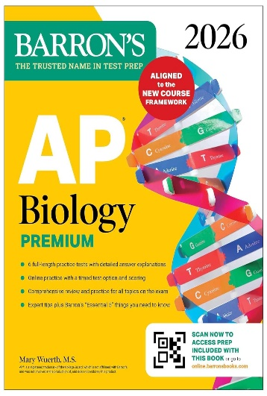

**I suggest buying other prep books as well, for extra review, such as the Princeton Review AP Biology prep book, or the Kaplan AP Biology prep book, but it is not required. There are many others to choose from, as well.

2) Also, purchase a formal lab notebook, which is basically a composition lined paper notebook shown below.

