GENERAL

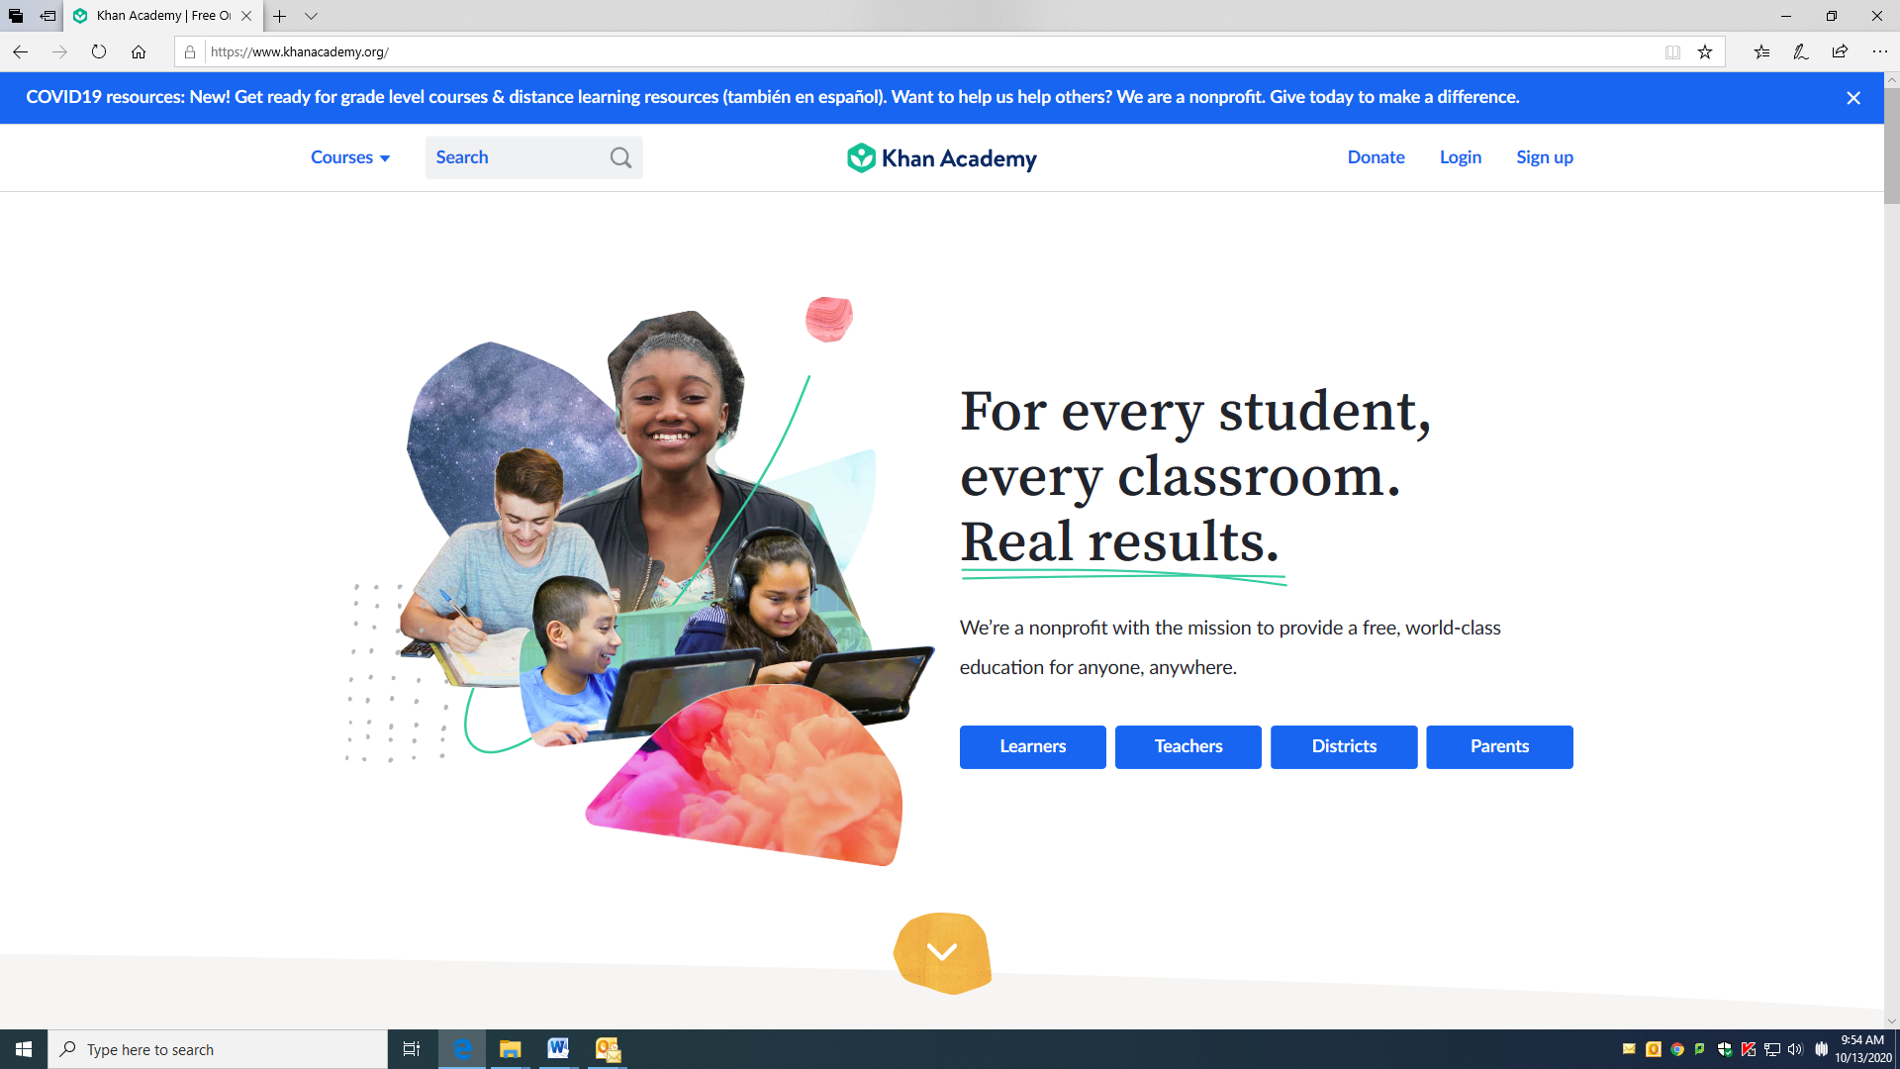

Khan Academy

https://www.khanacademy.org/

Khan Academy Districts offers additional features for district-level users who are in search of a stable, wider-scale solution, in addition to Khan Academy's free world-class curriculum, our Mastery learning system, and actionable teacher insights.

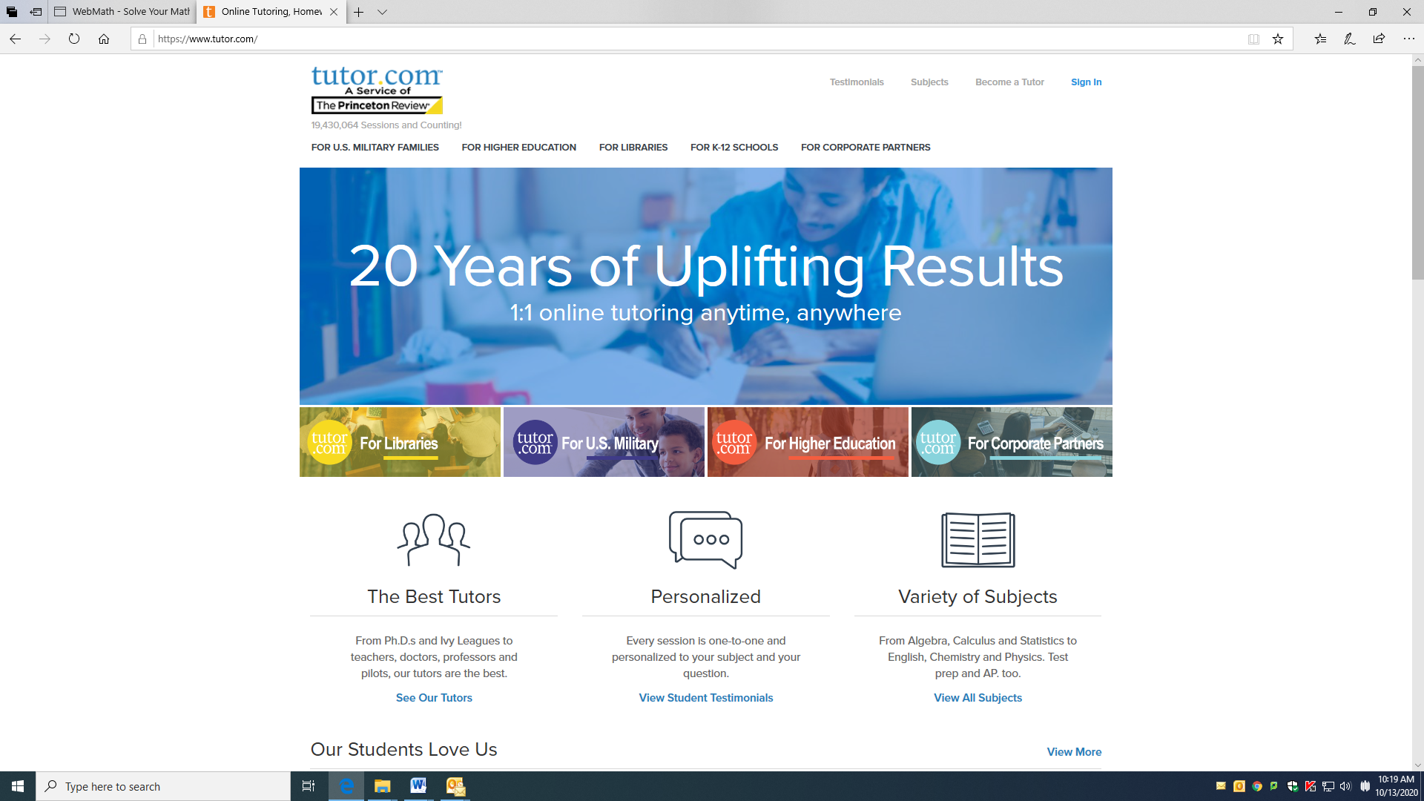
Tutor.com
https://www.tutor.com/
1:1 online tutoring. Anytime, Anywhere
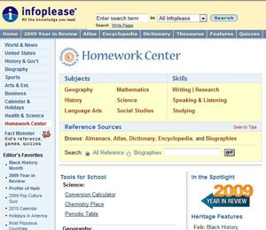
Infoplease: Homework Center
https://www.infoplease.com/homework-help/homework
From education company Pearson, this site is a great spot for looking up facts and background information. It’s organized by subject (history, language arts, math) or skill (research, studying), and also has quizzes and slideshows. For instance, drill down into the social studies section to read up on national anthems and the U.S. Constitution, or take a quiz on First Ladies or the Bill of Rights. The Fact Monster section—for younger kids—offers information, games, and quizzes.

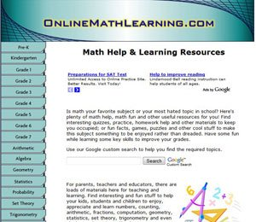

Math Help
Math help, quizzes, practices, fun facts, puzzles, videos and games to make numbers, counting, fractions, statistics, and the rest of it enjoyable. The companion site, Interactive Zone, lets kids create worksheets with auto-scoring, play games, or do simulations for more practice.

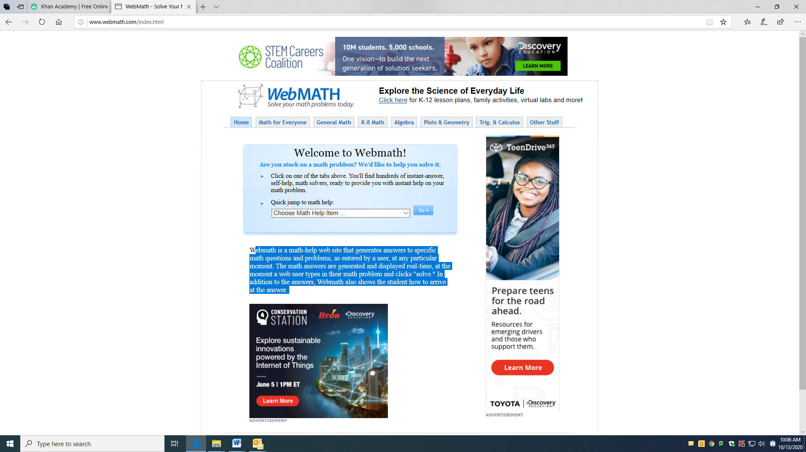

Webmath
http://www.webmath.com/index.html
Webmath is a math-help web site that generates answers to specific math questions and problems, as entered by a user, at any particular moment. The math answers are generated and displayed real-time, at the moment a web user types in their math problem and clicks "solve." In addition to the answers, Webmath also shows the student how to arrive at the answer.

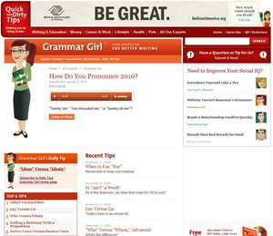

Grammar Girl

https://www.quickanddirtytips.com/grammar-girl/
Stumped about how to explain proper usage for “nor” versus “or”? Get help from this site, which contains full explanations on grammar, word choice, punctuation, or style. Answers are explained succinctly and efficiently—often via audio. This site also provides information to improve writing skills.
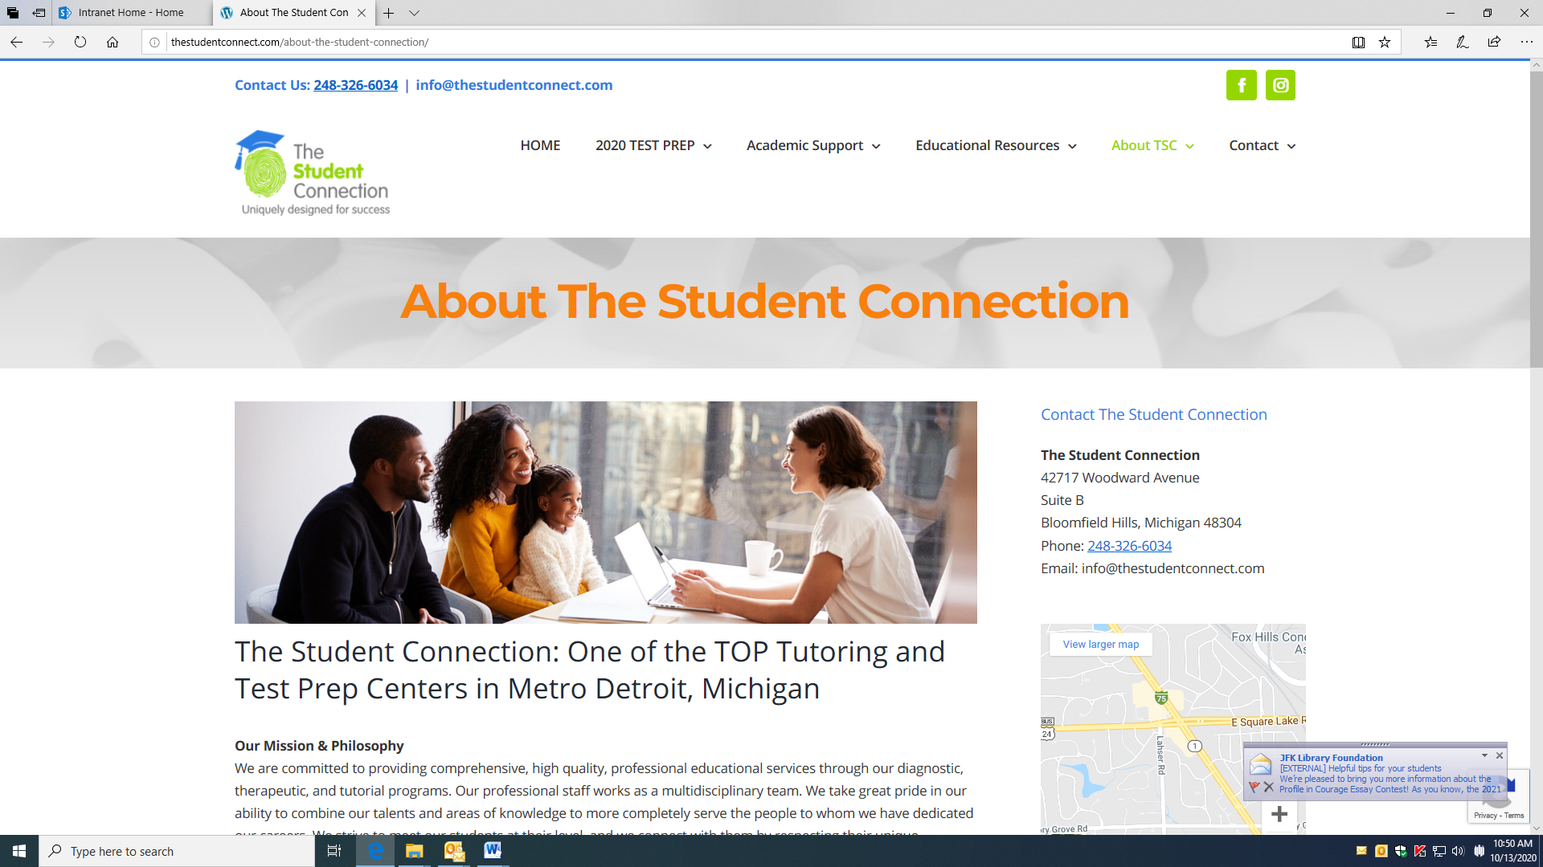
Student Connect
http://thestudentconnect.com/
We are committed to providing comprehensive, high quality, professional educational services through our diagnostic, therapeutic, and tutorial programs. Our professional staff works as a multidisciplinary team. We take great pride in our ability to combine our talents and areas of knowledge to more completely serve the people to whom we have dedicated our careers. We strive to meet our students at their level, and we connect with them by respecting their unique personalities.
Spanish Help
https://personal.colby.edu/~bknelson/SLC/
https://studyspanish.com/
Our online services and audio conversational course have helped thousands of serious students learn to speak Spanish fluently. As a true 21st century company, we do not suffer from geographic constraints. Our extensive network of experts and specialists extends across the globe.

All World Language Help
https://www.wordreference.com/

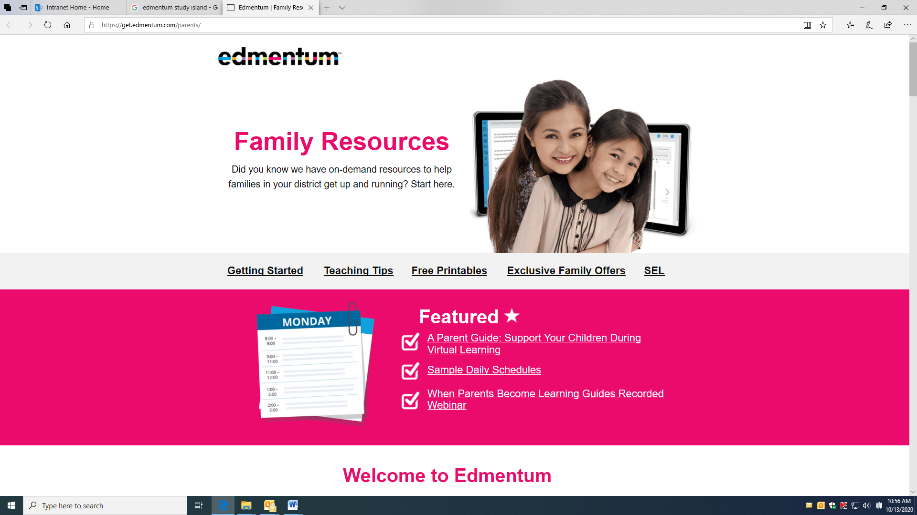

Edmentum Help
https://get.edmentum.com/parents/
Did you know we have on-demand resources to help families in your district get up and running? Start here.

