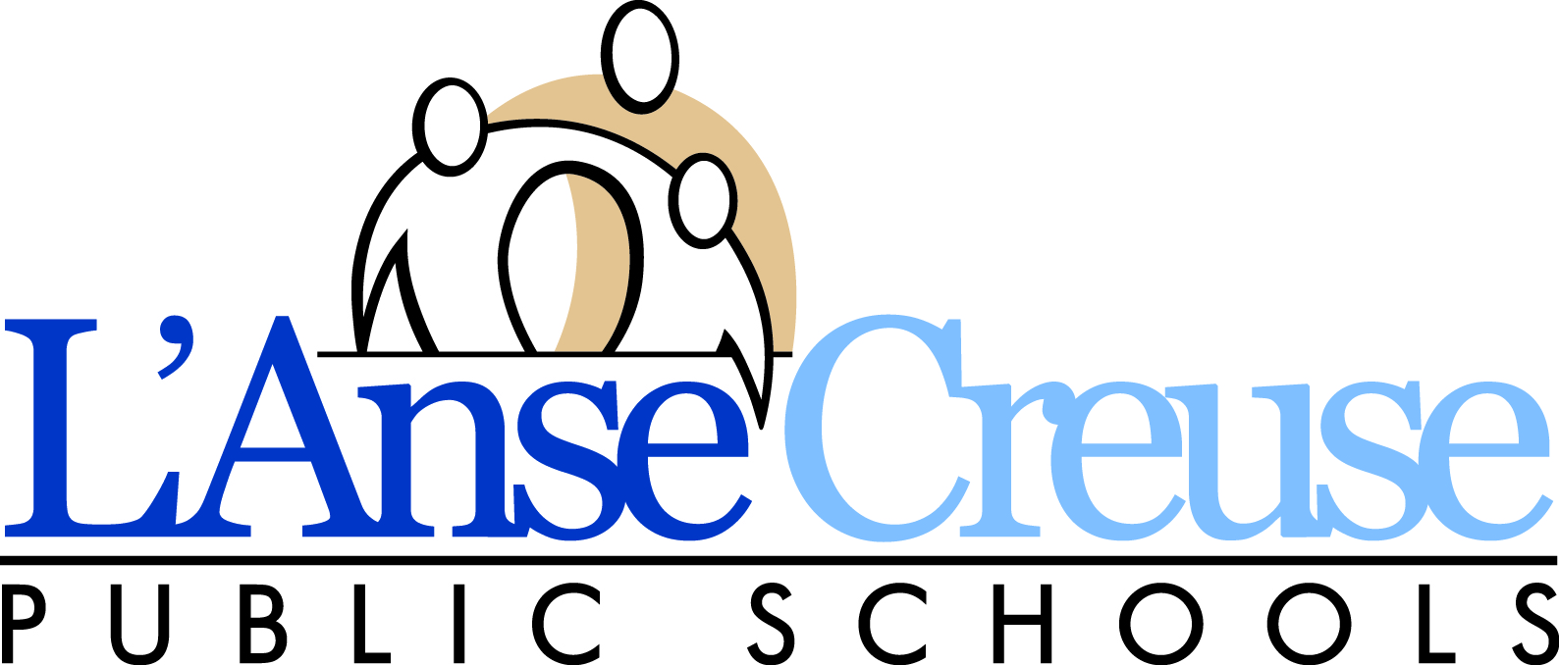

STUDENT RESIDENCY

This questionnaire is in compliance with the McKinney Vento Homeless Education Act. Your answers will help determine if the student meets eligibility requirements for services under the McKinney Vento Act. The McKinney Vento Homeless Education Act defines “homeless” as “individuals who lack a fixed, regular, and adequate nighttime residence”. This includes students who “are TEMPORARILY sharing the housing of other persons due to loss of housing or economic hardship.”

Student Name | Birthdate |  | Gender  M F | Grade Entering | School
Current Address (with apt/suite) |  | City |  |  |  | Zip

1. Is your current address above a temporary living arrangement? Yes No
(If you answer no to this question and this is a permanent living arrangement, skip to bottom of form and sign)

2. Is this temporary living arrangement due to loss of housing or economic hardship? Yes No
If you answered NO, you may stop here and sign the bottom of the form.
If you answered YES to the above questions, please complete the remainder of this form.

Where is the student currently living (check one box.)
Living in hotel/motel due to lack of other suitable housing |  | Name and address of hotel/motel:
Living in shelter or other temporary housing |  | Name of agency:
Car, campsite, or on the street

Temporary living arrangement by choice that is a fixed, regular, and adequate nighttime residence.

Doubled up: temporarily with friends/family due to loss of housing or economic hardship which does not meet the fixed, adequate or regular
nighttime residence.
Date the student moved to this address:

Are you seeking permanent housing? Yes No

Please Answer the Following Questions:
Any preschool-aged children living in home
Yes No | Name: |  | Birthdate:
 | Name: |  | Birthdate:
Previous Street Address (with apt/suite) | City & Zip |  | School District Attended
Reason for Leaving Previous Address

Residency and Educational Rights

Students without fixed, regular, and adequate living situations have the following rights:
- Immediate enrollment in the school they last attended or the local school where they are currently staying even if they do not have all the documents normally required at the time of enrollment without fear of being separated or treated differently due to their housing situations.
- Transportation to the school of origin for the regular school day.
- Access to free meals, Title 1 and other educational programs.
Any questions about these rights can be directed to the local McKinney-Vento Liaison at 586-783-6300 x1010 or the State Coordinator at 517-373-6066.
By signing below, I acknowledge that I have received and understand the above rights and that the information I have provided is true and accurate. False statements may be punishable by law.

Parent/Guardian Name (please print) | Date
Parent/Guardian Signature | Cell Phone

Student Residency 11.7.18

